*Answer the following questions as you view Bozeman’s* [*Chi-Squared Test*](http://www.bozemanscience.com/chi-squared-test/) *podcast.*

1. What is the purpose of the Chi-Squared test in science?
2. Using the formula, state what each variable represents.

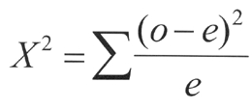

1. What does the null hypothesis state?
2. How is “degrees of freedom” determined?
3. What does it mean when you use the alpha value (p-value) 0.05 in order to look up the critical value?
4. What does it mean if the chi-square value is HIGHER than the critical value?
5. What does it mean if the chi square value is LOWER than the critical value?
6. You flip a coin a 100 times. You get 55 heads and 45 tails. Are the results statistically significant? Explain.

**PRACTICE PROBLEM:**

You design an experiment to test the question: Do *Drosophila* prefer rotting or fresh vegetation? You construct a choice chamber containing a rotting tomato on one side and a fresh tomato on the other. After observing the 100 *Drosophila* for 20 minutes, you find an average of 61.6 flies on the rotten side and an average of 38.4 flies on the fresh side.

1. State the null hypothesis (Ho):

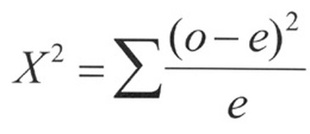

1. Perform a chi-square analysis using the data you collected during your experiment.

|  |  |  |  |  |
| --- | --- | --- | --- | --- |
| **Choice Chamber** | **Observed (o)** | **Expected (e)** | **(o-e)** | **(o-e)2/e** |
|  |  |  |  |  |
|  |  |  |  |  |
|  | **Total=** |  |  | **Sum (X2)=** |

1. Interpret the results of the chi-square analysis. Be sure to include the following information in your summary:

* How does the chi-squared value compare to the critical value?
* Should the null hypothesis be rejected or fail to be rejected?
* What does this say about the organisms of interest?
* Propose a model for how your organism responds to environmental cues.